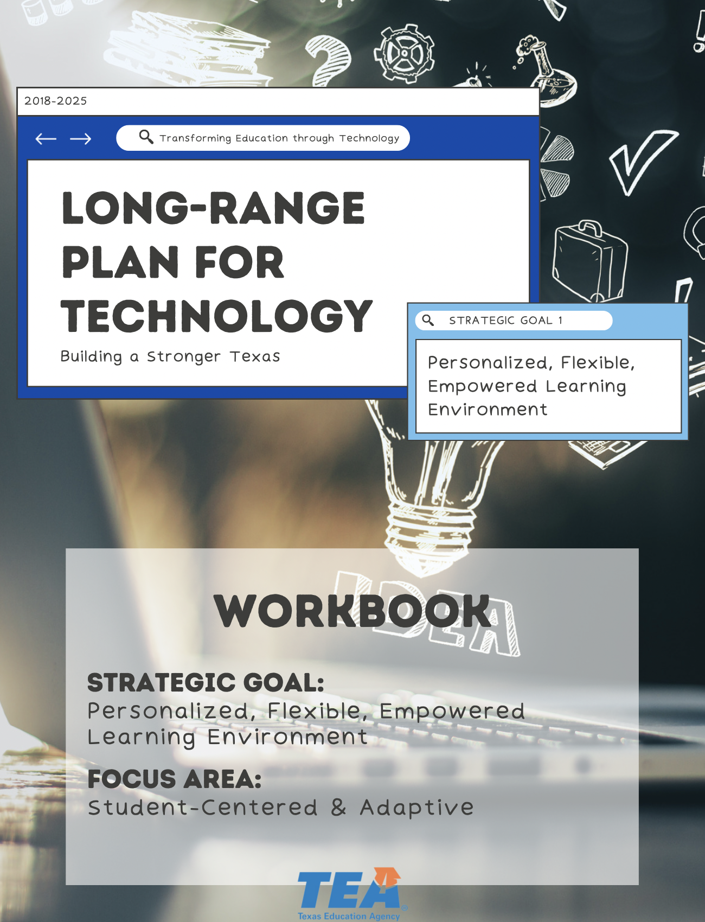

1. Take Note & Reflect:
How would you define the desired impact of learning in your district?

2. Take Note & Reflect:
What does a successful learning environment include for your district?

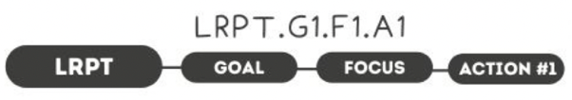

1. Take Note & Reflect:
Use this space to outline resources, assumptions, outcomes, roles & responsibilities, and budget for your strategic implementation plan.

2. Take Note & Reflect:
What are your current structures, policies, and technologies in place? How are new policies and structures like this working? Use the wins and struggles to inform your decision about how to move forward.

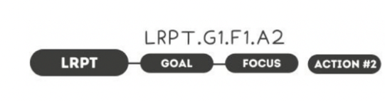

1. Take Note & Reflect:
Reflect on how you are already collaborating with stakeholders. Does your current model hold space for technology, PD, and curriculum & instruction in your district?

2. Take Note & Reflect:
Reflect on how you will keep this type of collaboration sustainable for continued use.

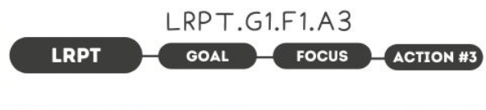

1. Take Note & Reflect:
Take a moment to on reflect on the strategies and models currently being used and tested in your district. What has been proven? What has brought successful results? Are there professional development strategies that you have used that you will carry forward?

2. Take Note & Reflect:
What outside models can be adapted to meet the methodologies and values of your district?

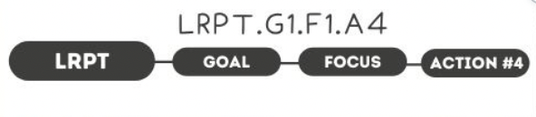

1. Take Note & Reflect:
We know what personalized learning is, how are we using that for the educators/parents as well as students?

2. Take Note & Reflect:
What training are you currently providing? How could it be adapted to provide opportunities for more personalized learning?

3. Take Note & Reflect:
Use this space to reflect on digital literacy in your district.

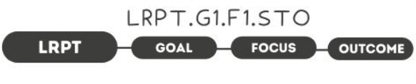

1. Take Note & Reflect:
How would you measure creative and innovative work in your district?

2. Take Note & Reflect:
Think about how you would make personalized content adaptive from year to year. What systems will you have in place to ensure the practice continues to build on itself? Will you rely mostly on software for data management? Who will oversee this?

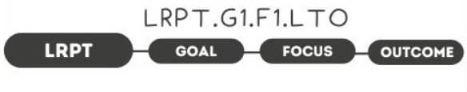

1. Take Note & Reflect:
What would a tech-savvy student population look like at your school? What traits would these students have? What tools would they need starting now?

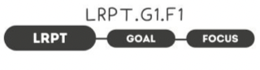

1. Take Note & Reflect:
Write a short summary statement for this focus area. How would you summarize what you've done and what you need to do for this focus area based on your work so far?

