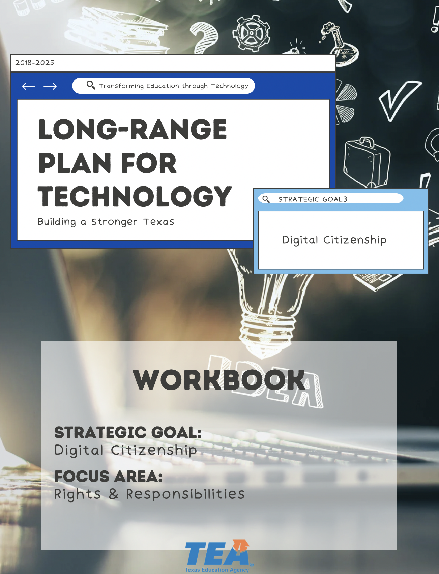

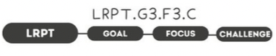

1. Take Note & Reflect:
Looking at your student population, do you see more students with limited guidance from parents or mixed messages on digital rights and responsibilities?

2. Take Note & Reflect:
How are you leading the conversation on digital rights and responsibilities within your community?

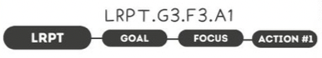

1. Take Note & Reflect:
How is respect defined in your district? How does your digital citizenship program address respect regarding digital etiquette, digital access, and digital law?

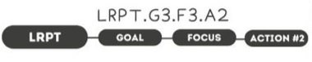

1. Take Note & Reflect:
Use this space to reflect on how your district is educating and connecting with others. What guidelines do you have in your program that address digital literacy, digital communication, and digital commerce?

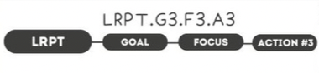

1. Take Note & Reflect:
Reflect on the guidelines that you have in place to address protection in digital rights, digital security, and digital health and wellness. How will you continue to enhance these guidelines as students and technology grow and evolve?

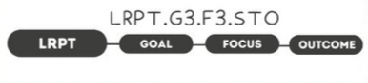

1. Take Note & Reflect:
Reflect over the guidelines we have discussed for Responsible Users. How would you create and measure a safe, responsible, and respectful use of the digital environment?

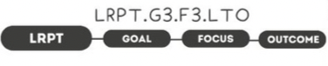

1. Take Note & Reflect:
What adjectives would your district use to describe a digital responsible society?

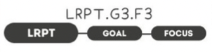

1. Take Note & Reflect:
Write a short summary statement for this focus area. How would you summarize what you've done and what you need to do for this focus area based on your work so far?

