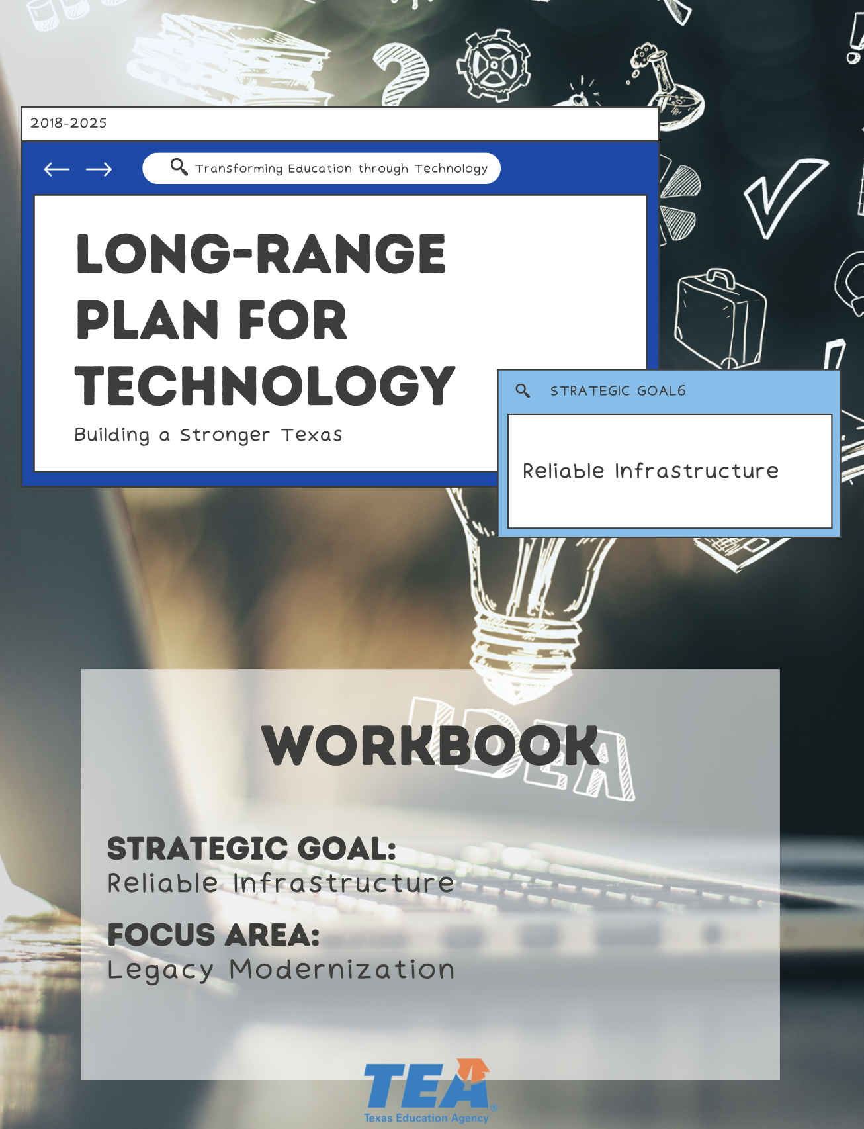

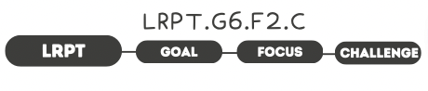

1. Take Note & Reflect:
Reflect on your district. What does your legacy modernization process look like?

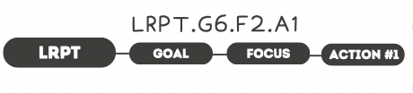

1. Take Note & Reflect:
List what comes to mind when you think of SAAS and/or COTS solutions your district uses regularly.

2. Take Note & Reflect:
Reflect on What Saas (software-as-a-service) and COTS (commercial-off-the-shelf) solutions are being used in your district. Has your district built a custom application? What were the results?

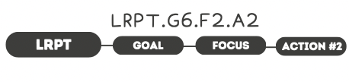

1. Take Note & Reflect:
What is your district's application portfolio management solution? How can you continue to grow this practice?

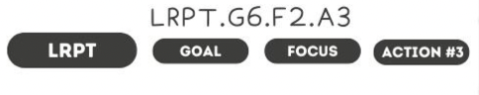

1. Take Note & Reflect:
What are your district's current standards for refresh and replacement of student/staff devices? Does this plan address the need for current licensing and hardware?

2. Take Note & Reflect:
Review your refresh cycle and your guidelines for outdated devices and software. What would it look like to shorten the refresh cycle from 5 years to 3 years? What strategies are in place to prevent the risk of inadvertent use that could pose a security risk?

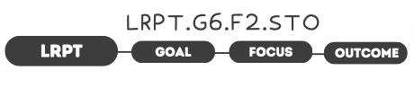

1. Take Note & Reflect:
Reflect on what repeatable, adaptable methodologies are in place to prioritize legacy modernization in your district. What positive impact would your learning environments experience with these processes in place?

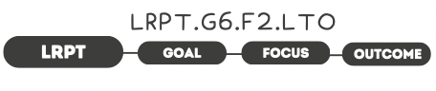

1. Take Note & Reflect:
How would a focus on emerging technologies impact your district?

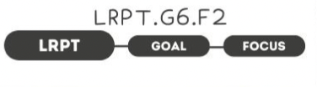

1. Take Note & Reflect:
Write a short summary statement for this focus area. How would you summarize what you've done and what you need to do for this focus area based on your work so far?

