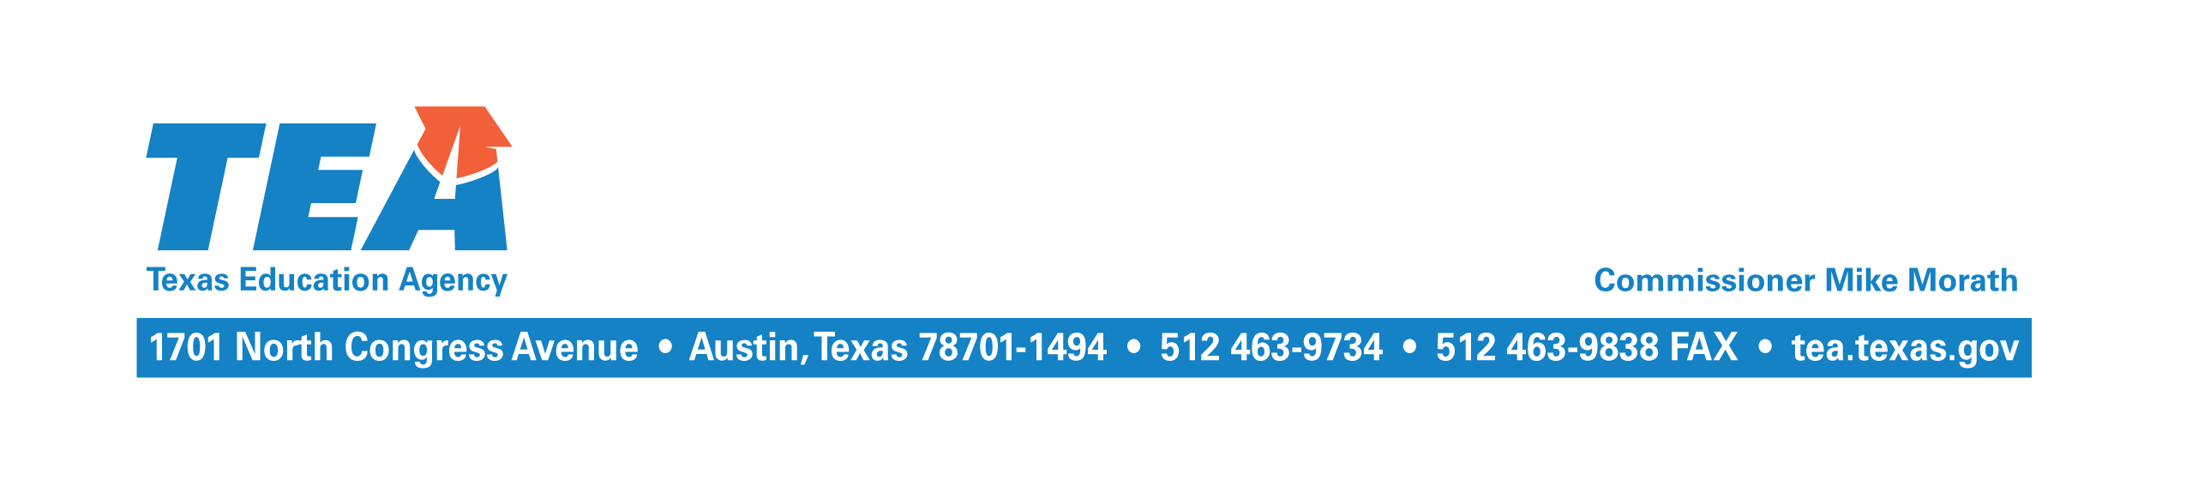

June 6, 2018

Re: 2018– 2019 Optional Flexible School Day Program (OFSDP)

To the Administrator Addressed:

The OFSDP is a program, authorized under the Texas Education Code (TEC), §29.0822 and 19 Texas Administrative Code (TAC), §129.1027 that your school district (district) or open-enrollment charter school (charter school) may offer to provide flexible hours and days of attendance for students in any grade who meet one of the following criteria:

- the student is at risk of dropping out of school, as defined by the TEC, §29.081;
- the student, as a result of attendance requirements under the TEC, §25.092, will be denied credit for one or more classes in which the student has been enrolled;
- the student is attending a campus with an approved early college high school program designation;
- the student is attending a campus implementing an approved innovative campus plan; or
- the student is attending a community-based dropout recovery education program, as defined by TEC, §29.081 (e-1) or (e-2). (This criterion will take effect once the pending, proposed amendments to 19 TAC, §129.1027 become effective—likely on August 1, 2018.)

Participation in the program additionally requires the student, if less than 18 years of age and not emancipated by marriage or court order, and the student’s parent, or person standing in parental relation to the student, to agree in writing to the student’s participation.

The goal of the program is to improve graduation rates for students who are in danger of dropping out of school, have dropped out, or who are behind in core subject courses.

A student may receive instruction and earn minutes of attendance in both classes held during the regular school day and classes specifically designed for the OFSDP. However, the student must not be simultaneously enrolled in the traditional program (average daily attendance (ADA) eligibility codes 1-6) and the OFSDP attendance program (ADA eligibility codes 7-8). For an eligible OFSDP student attending summer school for credit recovery, funding is limited to only funding the minutes necessary for the student to recover class credit. The sum of traditional ADA, OFSDP ADA and OFSDP credit recovery ADA must not exceed one ADA total.

Instruction time for the OFSDP is funded at the same rate under the FSP formulas as attendance for ADA in the traditional program; however, a single course cannot accrue more than 10,800 minutes, and a full-time equivalent student is expected to have a total of 43,200 minutes of instruction per year to generate one ADA.

House Bill 3706 amended TEC §29.081 to specify that a dropout recovery education program can be offered either on site at a campus or through an internet based online program. Among other provisions, online dropout recovery education programs are specifically required to:

- include as part of its curriculum credentials, certifications, and other course offerings that relates directly to employment in the state;
- provide an academic coach or local advocate for each student;
- use an individual learning plan to monitor each student’s progress, and
- track the number of minutes the student is receiving instruction online.

Beginning with the 2018-2019 TSDS PEIMS summer submission, districts and charter schools will be required to report participation in the OFSDP online programs as code 11, a new code on the C182-NON-CAMPUS-BASED-INSTRUCTION CODE table, and as code 6, a new code on the C177-FLEXIBLE-ATTENDANCE-PROGRAM-TYPE-CODE table. Additionally, these calendar tracks should be reported as code 5 on the C215 – INSTRUCTIONAL-PROGRAM-TYPE table.

To participate in the OFSDP, your district or charter school must submit an annual application notifying the Texas Education Agency (TEA) that it plans to participate. The application requires the following information: 1) implementation plan description, 2) a completed Participating Campus, Student Eligibility, and Period of Agreement Template 3) staff plans, 4) schedules, and 5) student attendance accounting security procedures and documentation.

Please note that the district or charter school may not begin the program prior to receiving application approval from TEA.

If you have questions about the program, please contact Melani Escobar by email at Melani.Escobar@tea.texas.gov or by phone at (512) 463-4834.

The rules, application, template and attendance guidelines for the OFSDP can be found at: http://tea.texas.gov/Finance_and_Grants/State_Funding/Additional_Finance_Resources/Optional__Flexible_School_Day_Program/.

Sincerely,

Al McKenzie
Director, State Funding
AM/nr

