HTML PARENT EMAIL BLAST

VISUAL PREVIEW:
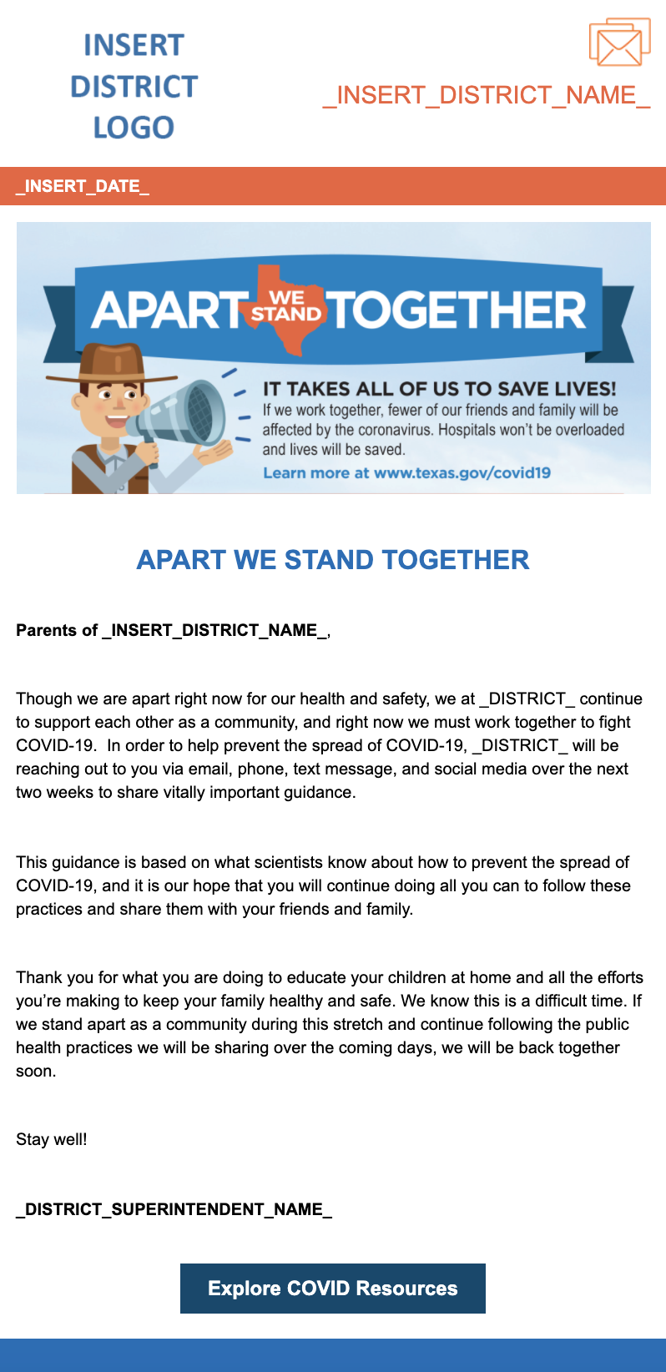

SOURCE CODE:

<table class="gd_tbl_wrap" border="0" width="100%" cellspacing="0" cellpadding="0" align="center">
<tbody>
<tr>
<td style="background-color: #eeeeee; margin: 0; padding: 0; width: 100% !important;" bgcolor="#eeeeee">
<table id="yahoo" class="main-table" style="width: 600px; border-collapse: collapse;" width="600" cellspacing="0" cellpadding="0" align="center">
<tbody>
<tr>
<td>
<table class="main-table" style="border-collapse: collapse;" width="100%" cellspacing="0" cellpadding="0" align="center">
<tbody>
<tr>
<td id="view-in-browser" class="thin" style="padding: 10px;" width="100%" data-govdstyle="all" data-govdtitle="View in Browser">
<p class="gd_p" style="text-align: center; line-height: 1.1; color: #666666; font-family: arial, helvetica, sans-serif; font-size: 10px; margin: 0;" align="center">[[VIEW_THIS]]</p>
</td>
</tr>
</tbody>
</table>
</td>
</tr>
<tr>
<td id="header-bg" style="background-color: #ffffff;" bgcolor="#FFFFFF" data-govdstyle="all" data-govdtitle="Header Background">
<table class="main-table" style="border-collapse: collapse;" width="100%" cellspacing="0" cellpadding="0" align="center">
<tbody>
<tr>
<td class="tablecell" align="left" valign="top" width="40%">
<table style="border-collapse: collapse;" width="100%" cellspacing="0" cellpadding="0" align="left">
<tbody>
<tr>
<td id="main-header" style="padding: 15px;" width="100%" data-govdstyle="all" data-govdtitle="Main Header"><img class="govd_template_image" src="https://content.govdelivery.com/attachments/fancy_images/TXTEA/2020/03/3255081/insert-logo_original.png" alt="insert_logo" width="210" height="121" style="width: 210px; height: auto !important; max-height: auto !important; border: none;" /></td>
</tr>
</tbody>
</table>
</td>
<td class="tablecell" align="right" valign="top" width="60%">
<table style="border-collapse: collapse;" width="100%" cellspacing="0" cellpadding="0" align="left">
<tbody>
<tr>
<td id="main-header-2" style="padding: 15px;" align="right" width="100%" data-govdstyle="all" data-govdtitle="Main Header 2"><img class="govd_template_image" src="https://content.govdelivery.com/attachments/fancy_images/TXTEA/2017/07/1455045/correspondenceicon_original.png" alt="Correspondence" width="55" height="45" style="width: 55px; height: auto !important; max-height: auto !important; border: none;" />
<p class="gd_p" style="text-align: right; line-height: 1.4; color: #f06039; font-family: arial, helvetica, sans-serif; font-size: 22px; margin: 10px 0;" align="right">_INSERT_DISTRICT_NAME_</p>
</td>
</tr>
</tbody>
</table>
</td>
</tr>
</tbody>
</table>
</td>
</tr>
<tr>
<td id="date-bg" style="background-color: #f06039;" bgcolor="#f06039" data-govdstyle="all" data-govdtitle="Date Background">
<table class="main-table" style="border-collapse: collapse;" width="100%" cellspacing="0" cellpadding="0" align="center">
<tbody>
<tr>
<td id="main-date" class="thin" style="padding: 10px 15px;" width="100%" data-govdstyle="all" data-govdtitle="Main Date">
<p class="gd_p" style="text-align: left; line-height: 1.1; color: #ffffff; font-family: arial, helvetica, sans-serif; font-size: 15px; margin: 0;" align="left"><strong>_INSERT_DATE_<br /></strong></p>
</td>
</tr>
</tbody>
</table>
</td>
</tr>
<tr>
<td>
<table class="main-table" style="border-collapse: collapse;" width="100%" cellspacing="0" cellpadding="0" align="center">
<tbody>
<tr>
<td id="main-body" style="background-color: #ffffff; padding: 15px;" bgcolor="#FFFFFF" width="100%" data-govdstyle="all" data-govdtitle="Main Body"><img class="govd_template_image" src="https://content.govdelivery.com/attachments/fancy_images/TXTEA/2020/03/3255070/3018221/apart-hero_crop.png" alt="Apart Together Hero" width="570" height="245" style="width: 570px; height: auto !important; max-height: auto !important; border: none;" />
<h1 style="text-align: center; line-height: 1.1; font-weight: bold; color: #0d6cb9; font-family: arial, helvetica, sans-serif; font-size: 24px; margin: 10px 0;" align="center">&nbsp;</h1>
<h1 style="text-align: center; line-height: 1.1; font-weight: bold; color: #0d6cb9; font-family: arial, helvetica, sans-serif; font-size: 24px; margin: 10px 0;" align="center">APART WE STAND TOGETHER</h1>
<p style="line-height: 1.4; color: #000000; font-family: arial, helvetica, sans-serif; font-size: 15px; text-align: left; margin: 10px 0;" align="left">&nbsp;</p>
<p style="line-height: 1.4; color: #000000; font-family: arial, helvetica, sans-serif; font-size: 15px; text-align: left; margin: 10px 0;" align="left"><strong>Parents of _INSERT_DISTRICT_NAME_</strong>,</p>
<p style="line-height: 1.4; color: #000000; font-family: arial, helvetica, sans-serif; font-size: 15px; text-align: left; margin: 10px 0;" align="left">&nbsp;</p>
<p style="line-height: 1.4; color: #000000; font-family: arial, helvetica, sans-serif; font-size: 15px; text-align: left; margin: 10px 0;" align="left">Though we are apart right now for our health and safety, we at _DISTRICT_ continue to support each other as a community, and right now we must work together to fight COVID-19. &nbsp;In order to help prevent the spread of COVID-19, _DISTRICT_ will be reaching out to you via email, phone, text message, and social media over the next two weeks to share vitally important guidance.</p>
<p style="line-height: 1.4; color: #000000; font-family: arial, helvetica, sans-serif; font-size: 15px; text-align: left; margin: 10px 0;" align="left">&nbsp;</p>
<p style="line-height: 1.4; color: #000000; font-family: arial, helvetica, sans-serif; font-size: 15px; text-align: left; margin: 10px 0;" align="left">This guidance is based on what scientists know about how to prevent the spread of COVID-19, and it is our hope that you will continue doing all you can to follow these practices and share them with your friends and family.</p>
<p style="line-height: 1.4; color: #000000; font-family: arial, helvetica, sans-serif; font-size: 15px; text-align: left; margin: 10px 0;" align="left">&nbsp;</p>
<p style="line-height: 1.4; color: #000000; font-family: arial, helvetica, sans-serif; font-size: 15px; text-align: left; margin: 10px 0;" align="left">Thank you for what you are doing to educate your children at home and all the efforts you&rsquo;re making to keep your family healthy and safe. We know this is a difficult time. If we stand apart as a community during this stretch and continue following the public health practices we will be sharing over the coming days, we will be back together soon.</p>
<p style="line-height: 1.4; color: #000000; font-family: arial, helvetica, sans-serif; font-size: 15px; text-align: left; margin: 10px 0;" align="left">&nbsp;</p>
<p style="line-height: 1.4; color: #000000; font-family: arial, helvetica, sans-serif; font-size: 15px; text-align: left; margin: 10px 0;" align="left">Stay well!</p>
<p style="line-height: 1.4; color: #000000; font-family: arial, helvetica, sans-serif; font-size: 15px; text-align: left; margin: 10px 0;" align="left">&nbsp;</p>
<p style="line-height: 1.4; color: #000000; font-family: arial, helvetica, sans-serif; font-size: 15px; text-align: left; margin: 10px 0;" align="left"><strong>_DISTRICT_SUPERINTENDENT_NAME_</strong></p>
<p style="line-height: 1.4; color: #000000; font-family: arial, helvetica, sans-serif; font-size: 15px; text-align: left; margin: 10px 0;" align="left">&nbsp;</p>
<h3 style="text-align: center; line-height: 1.1; font-weight: bold; color: #000000; font-family: arial, helvetica, sans-serif; font-size: 18px; margin: 20px 0;" align="center"><a href="http://texas.gov/covid19" target="_blank" style="color: #ffffff; text-decoration: none; -ms-word-break: break-all; word-break: break-word; -webkit-hyphens: none; -moz-hyphens: none; hyphens: none; background-color: #00486e; border-color: #00486e; border-style: solid; border-width: 12px 25px;" rel="noopener">Explore COVID Resources</a></h3>
</td>
</tr>
</tbody>
</table>
</td>
</tr>
<tr>
<td id="footer-bg" style="background-color: #0d6cb9;" bgcolor="#0D6CB9" data-govdstyle="all" data-govdtitle="Footer Background">
<table class="main-table" style="border-collapse: collapse;" width="100%" cellspacing="0" cellpadding="0" align="center">
<tbody>
<tr>
<td id="main-footer" style="background-color: #0d6cb9; padding: 15px 15px 0px;" bgcolor="#0D6CB9" width="100%" data-govdstyle="all" data-govdtitle="Main Footer">&nbsp;</td>
</tr>
<tr>
<td id="social" style="background-color: #0d6cb9; padding: 0px 15px 15px;" align="center" bgcolor="#0D6CB9" width="100%" data-govdstyle="all" data-govdtitle="Social">&nbsp;</td>
</tr>
</tbody>
</table>
</td>
</tr>
</tbody>
</table>
</td>
</tr>
</tbody>
</table>

