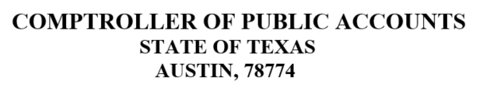

WIRING INSTRUCTIONS FOR COMPTROLLER FED ACCOUNT ROUTING NUMBER: 114900164
FED ACCOUNT NAME: TX COMP AUSTIN ACCOUNT NUMBER: 463600701
ACCOUNT NAME: CPA / TEXAS EDUCATION AGENCY REFERENCE: (ANYWHERE ISD)
ATTENTION: TEA RECAPTURE

Be sure to indicate TEA and the name of the ISD on the wire transfer details.

If you have questions specific to the amount of your recapture payment or the wire transfer instructions, please contact the Excess Local Revenue program administrator in the TEA State Funding Division at (512) 463-9238.

